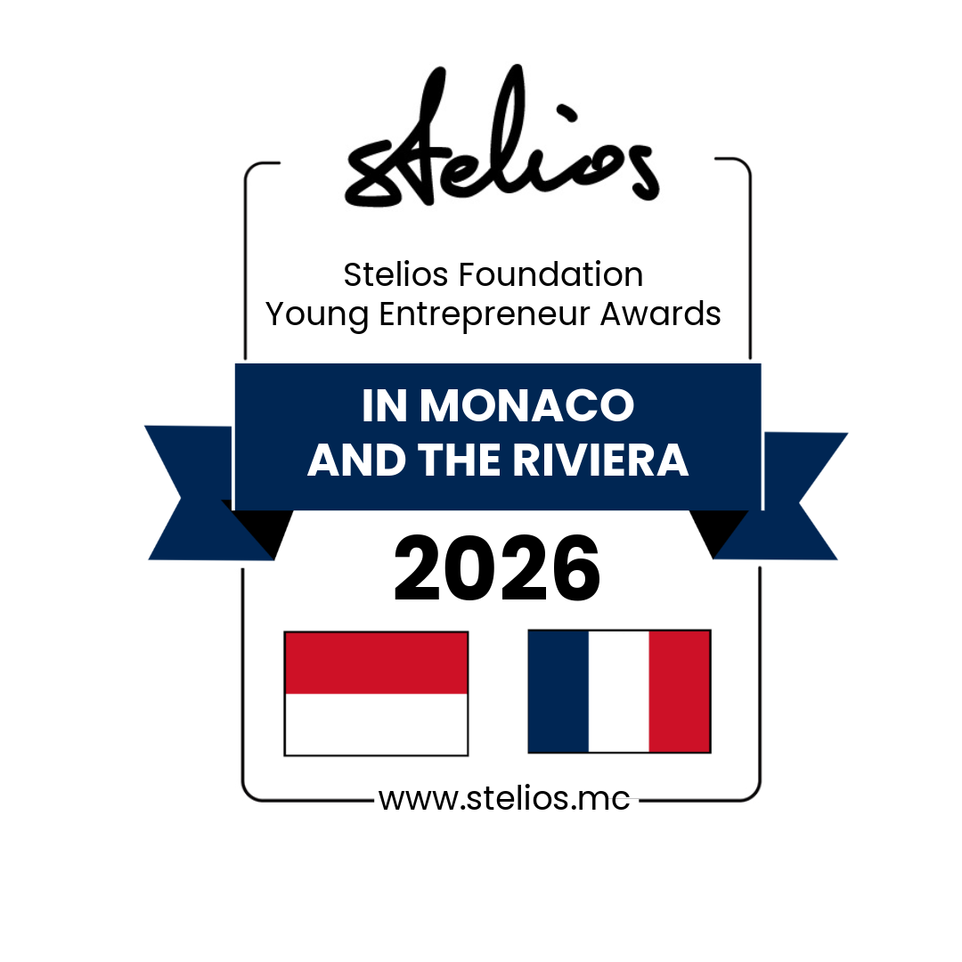
APPLICATION FORM
A total of €60,000 in cash prizes to be won by three young entrepreneurs in Monaco and the French Riviera!
With these new awards, the Stelios Foundation is rewarding start-up businesses in Monaco and the French Riviera that will create more new jobs in the economy!

- these cash prizes are offered by the Stelios Philanthropic Foundation (www.stelios.mc ) a Monaco registered charity created by Sir Stelios Haji-Ioannou, the creator and owner of the easy family of brands. For more information visit: www.easy.com and www.easyhistory.info.
- From 16 February 2026 until 15 April 2026, we are inviting applications - to be submitted on this application form available to download on the website https://stelios.mc/
and sent by email to liliana.farhat@stelios.com.
- The winners will be announced at an awards ceremony at the Stelios Foundation Conference Hall in Monaco on Thursday 21 May 2026.
- The overall winner will win a prize of €30,000, with a 2nd prize of €20,000, and a third prize of €10,000 to invest in their business.

CRITERIA TO APPLY:
- Entrepreneur must be 34 years old or younger (born in 1992 or later).
- Start-up company must have been registered at Registre du Commerce et des Sociétés (RCS) FRANCE, or Répertoire du Commerce et de l'Industrie (RCI) MONACO in the last five years (first registered in 2021 or later).
- With revenues of at least €50,000 per annum.
- Entrepreneur/applicant to own more than 50% of the shares in the company and be a director of the company.

DETAILS OF APPLICANT:
First name____________ Last name________________ Date of birth___________________

Email address__________________________________________________________________

LinkedIn profile of applicant____________________________________________________

Mobile phone__________________ What % of the company do you own?___________
How did you hear about these awards?_______________________________________

DETAILS OF THE COMPANY:
Legal name of company___________________________________________
Monaco RCI / France RCS ______________________________________
Incorporated on (date) ____________________________________________________
Phone number (fixed line) _________________
Company postal address__________________________________________________________
Company website (URL)___________________________________________________________
Visitors per month _______________ (most recent figure)
LinkedIn page of company ________________________________________________________

Financials | 2024 | 2025 | 2026 (Forecast)
Turnover €
Net profit € (or loss)
Number of staff
Number of customers served per year

Provide a brief description of your business, your customers, and markets in which you operate (maximum 1000 characters):

How would you describe your business (tick as many as applicable):

Business to consumer (B2C) ____ or Business to business (B2B) __________

Are you selling a physical product ____ or a service _________

The majority of your sales revenue is online via the internet ____ or you receive payment via offline payment methods _____

Name the three biggest direct competitors you have: _________________________

Your selling price point relative to your competitors is:
lower _____ average _____ premium _____

Without affecting your ability to win these awards, please tell us if you are willing to discuss in the future joining the easy family of brands with your current business ? yes___ no_______ if yes which easy brand would you like to use ? easy_________

Press/media: Please tell us about any press/media coverage you may have had, negative or positive. You may provide links if any. Please note failure to disclose negative press could exclude you from the awards.

________________________________________________________________________________

Social media: Please list all your active social media accounts across all platforms (LinkedIn, Facebook, Twitter or X, Instagram etc).
_____________________________________________________________________________

By applying for these awards, I hereby agree to:
- Allow the Stelios Foundation to process your data on the application form and publish the fact that you have applied and/or won.
- Follow the LinkedIn page of the Stelios Foundation Conference Hall Monaco:
- https://www.linkedin.com/showcase/stelios-foundation-conference-hall-monaco/posts/

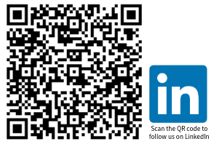

- Connect on LinkedIn with www.linkedin.com/in/lilianafarhat
- If you win an award, promote the awards on LinkedIn after the ceremony and include award details as a permanent logo on the footer of your business website homepage with a clickable link to the https://stelios.mc/
- If you win you will also be expected to promote subsequent year’s awards

I understand that all judging decisions in these awards are made by Sir Stelios and are final. I certify that the facts above are correct. I understand that the Stelios

Philanthropic Foundation will process any data that I have provided on this form and in any attachments for the promotion of the Awards.

Please fill in your details below confirming your application as stated above and email the word file to Liliana.farhat@stelios.com

Name of
applicant
Name of
Company
Date

